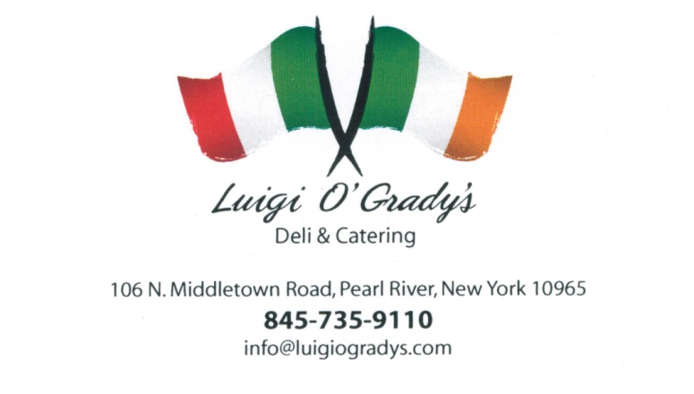
LUIGI O’GRADY’S MOTHER’S DAY SPECIAL
ORDER BY SAT 5/9 @ 4PM & PICK UP SUN 5/10 UP UNTIL 4PM
Family Dinners - $29.99 each
Each dinner feeds 2 adults and 2-4 children, NO SUBSTITUTIONS
#1 – Chicken Parm and Penne Vodka with Garden OR Caesar Salad, Bread and Butter
#2 – 12pc Fried Chicken(3pc each Breast, Thigh, Leg, and Wing) with Mashed Potatoes and Gravy, Corn and Mac and Cheese
#3 – Eggplant Rollatini with Spaghetti Marinara, Garden OR Caesar Salad, Bread and Butter
#4 – Meatloaf with Gravy, Mashed Potatoes, Peas &Carrots, Garden OR Caesar Salad, Bread and Butter
#5 – Spaghetti with Meatballs, Garden or Caesar Salad, Bread and Butter
#6 – Chicken Marsala OR Chicken Francaise with Rice Pilaf, Grilled Vegetables, Garden OR Caesar Salad, Bread and Butter
CALL 845-735-9110 TO ORDER

